*Not all incidents require a full mobilization of resources. Some are very local events of little long-term consequence and require less than full activation of your emergency action plan.*

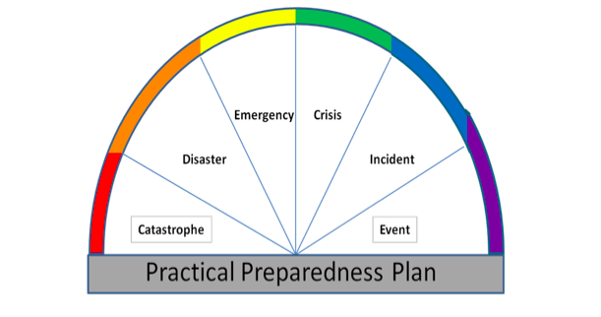

**Follow these steps to determine your degree of reaction to a disruptive incident.** **Based on your answers to these questions you can decide if a small, medium or full-scale activation of your emergency action plan is required.**

* Is the incident confined to a locale or section of the facility (e.g. wastebasket fire)?
* Is the health or safety of anyone at risk?
* Are adequate resources present to deal with the situation safely?
* Are the individuals currently onsite trained to deal with this type of situation?
* Does the incident pose the risk of escalating?
* Are you seeing a cascading of other effects such as loss of power
* Is there a danger that the incident could affect other tenants of the facility?